Aim – Project Document in database.

Learning outcome: Able to configure embedded databases with different web pages using MongoDB.

Duration: 2 hours

List of Hardware/Software requirements:

1. Laptop/Computer with Linux OS - Ubuntu 18.04 LTS
2. MongoDB 6.0.5 Community Edition

**Follow the below step’s**

Step -1 Open cmd then type mongosh. After it create a database which name is adit.

Type **use adit** is cmd is use to create a new database without any value.

Step -2 We insert at lest 10 value into **adit**. Use this cmd for inserting any document into the collection. **db.stu.insertOne({Id:1,Name:"payal",Lab:"php",CertificateNo:11, Course:"ibm", StartDate:2018,EndDate:2020})**.

Output:

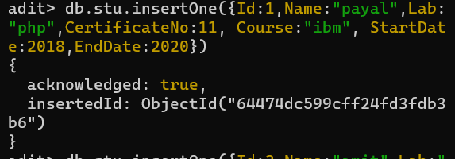

Step -3 Project document in database type **db.stu.find()** (this cmd is use to show all document)

Output:

